Progress Note

|  |  |  |
| --- | --- | --- |
| Date: Jan 24th | Start Time: 15:49 | End Time: 16:29 |
| Type of Contact: In person | Members Present: The Walker Family (Randy, Elizabeth, Matthew, and Faith) | |

Assessment Results: Genogram for the Walker Family (see the Appendix B)

Summary: In this session, I introduced the genogram (Family tree) to the Walker family to have a postural representation of family information. The genogram refers to the family tree, is a mapping technique provides conceptual views of family composition and family interactions. In the beginning, I gently confronted Elizabeth with the unchanged smelly diaper after asking Elizabeth about Matthew's potty training. I introduced the family tree, but the family did not have much knowledge about it. Randy was reluctant to draw the family tree, but Faith and Matthew were excited. I believe the Walker family had distant relationships because they didn't want corporate with other members to draw their map. Faith brings a real tree which consisted of Elizabeth, Matthew, Lucas and Uncle Jim. She mentioned she had no idea about her biological father. Elizabeth's genogram did not involve Randy but had Faith's birth father. She denied that she gave Lucas to her mother. When I asked her relationship with her children, she emphasized she had closed connection with Faith. Randy drew a very small genogram around the corner and connected his genogram to Elizabeth's with a wavy line. Randy was absent for most of the time, most of the time and he agreed with Elizabeth in their strong relationships. I felt Randy formally admitted his family structure, but he didn't know the purpose of the genogram. When we talked about their relationships before Matthew was born, they had more eye contact and emotional engagement. I noticed Randy and Elizabeth enjoyed in talking about their memory; they did not have the tensile conversation. Randy did not have any complaint about Lucas and his brother, Jim. This made me doubt that he was hiding things about his father and Elizabeth had some secrets about Lucas. Following their demonstration, they had a great time before Matthew was born; therefore, I hypothesize there was something happen between Elizabeth and Randy after Matthew was born interrupted their relationships. The Walk's family's problem needs comprehensive evaluations.

Plan: Introduce the Ecomap

Signature_______________________________________________________________

Appendix B

The Walker Family Genogram

Elizabeth’s genogram

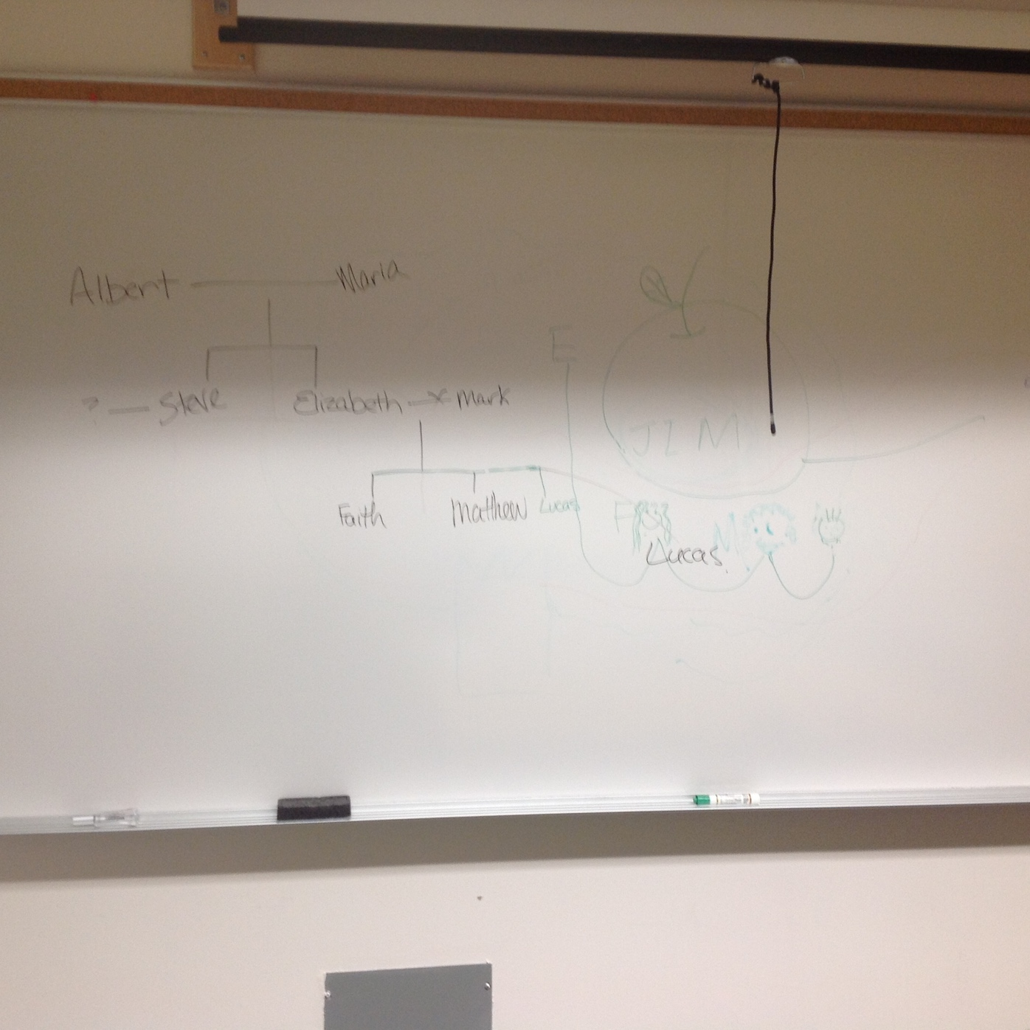

Faith and Matthew’s Genogram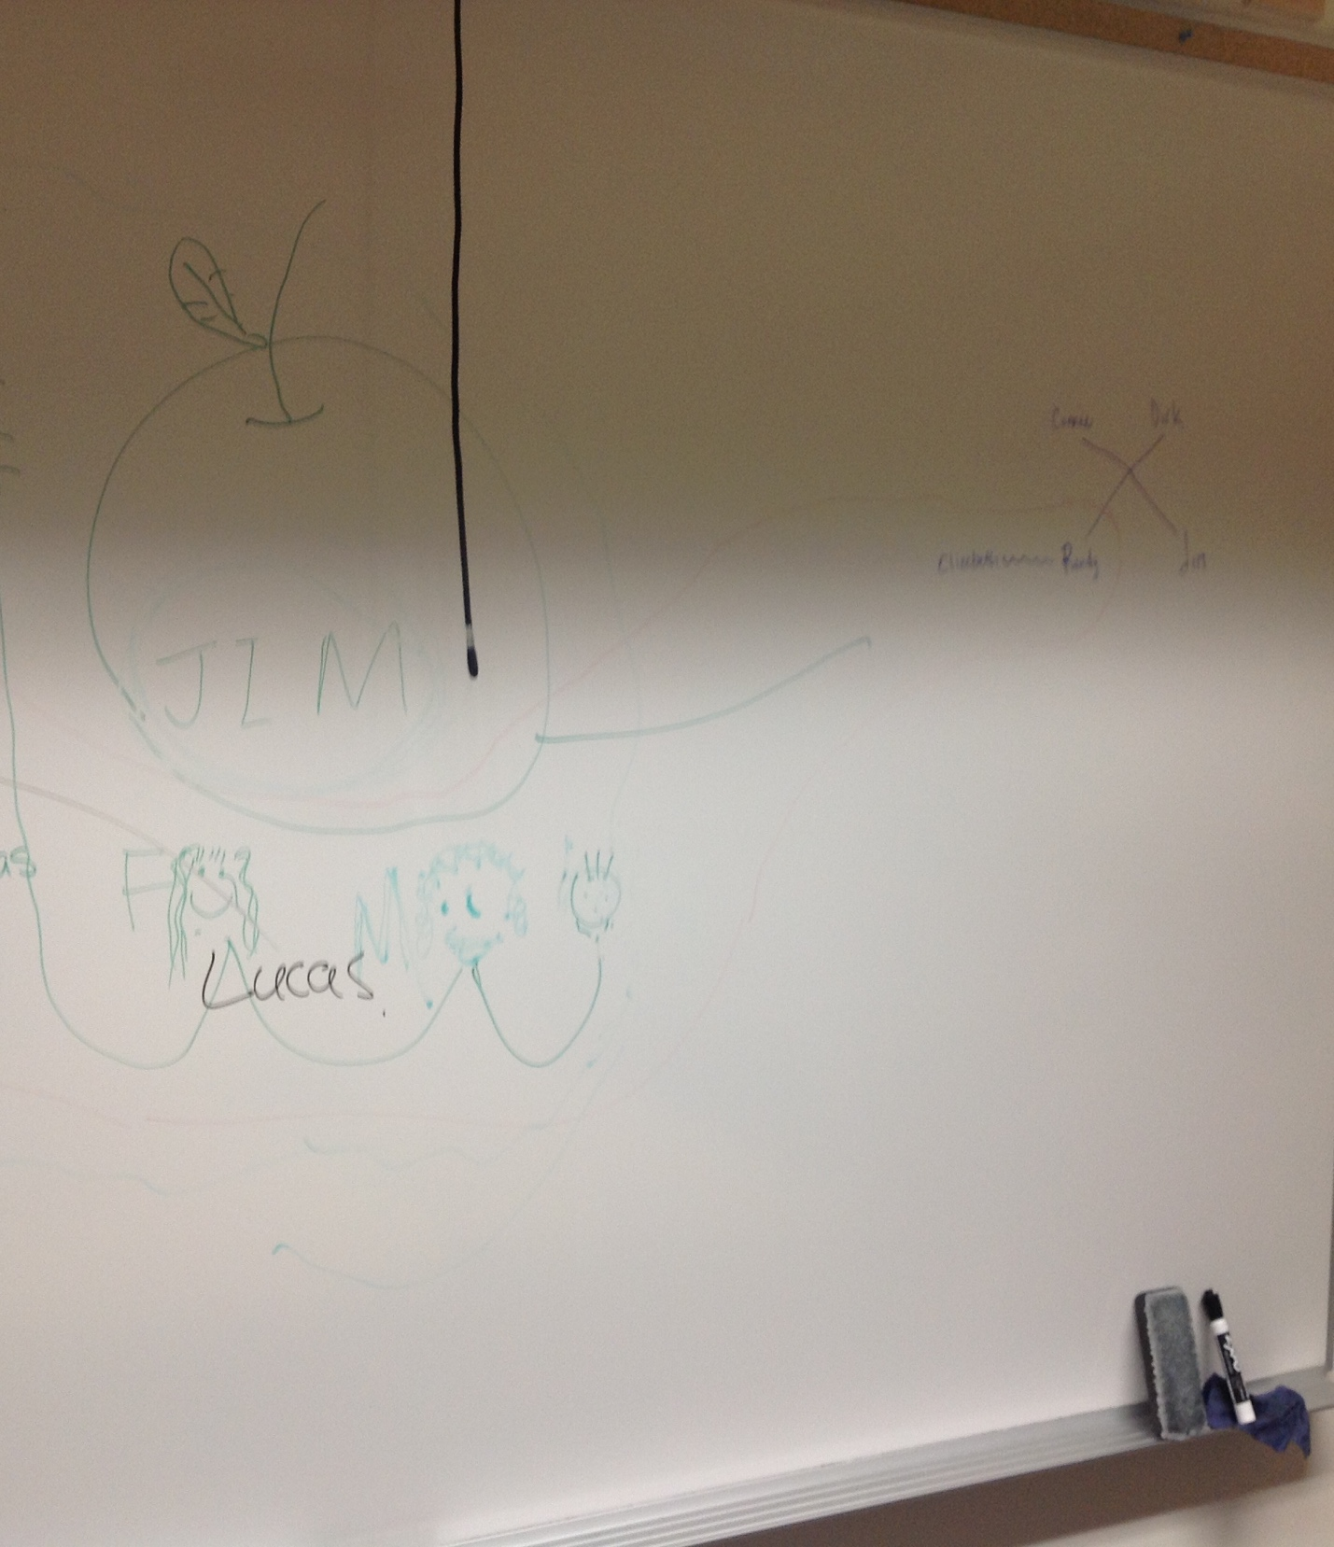

The walker family’s Genogram

